Interaction Design/ Pinciples

1. What is Interaction Design?
👉 Interaction Design (IxD) is about designing how users interact with a digital product (website, app, device).
It focuses on actions, responses, and feedback between the user and the system.
📌 Simply put → It’s not just about how something looks, but how it works, responds, and feels when a user interacts with it.

Why It Matters
- Enhances usability → makes products easy and intuitive to use.
- Builds user satisfaction → smooth interactions create positive experiences.
- Provides clear feedback → users understand what’s happening after each action.
- Boosts efficiency → helps users complete tasks quickly and effectively.
- Increases engagement & trust → well-designed interactions encourage continued use.

2. Goals of Interaction Design
- Make the product easy to use
- Provide clear feedback for every action
- Create a smooth user flow
- Reduce errors and confusion
- Make the product engaging & enjoyable
Screenshot:
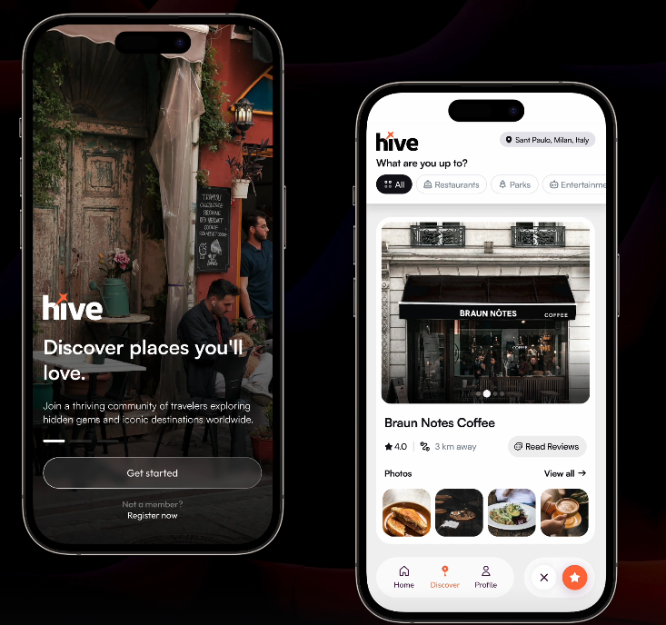

3. Principles of Interaction Design
Here are the key principles (sometimes called IxD principles) with examples:

🔹 1. Consistency
- Users expect similar actions to produce similar results.
- Consistent design builds familiarity and reduces the learning curve.
Example:
All “Save” buttons in an app look the same (icon, color, position) → user doesn’t get confused.

Why It Matters
- Reduces the learning curve → users don’t have to relearn basic actions each time.
- Builds trust and reliability → users feel confident that the system will behave as expected.
- Improves efficiency → consistent patterns help users complete tasks faster.
- Enhances usability across platforms → consistency makes transitions between devices seamless.
- Strengthens brand identity → a unified interaction style reinforces recognition.

🔹 2. Feedback
- Every action should give an immediate response.
- Feedback tells the user what happened.
Example:
- Button changes color when clicked
- Vibration when toggling a switch
- Upload progress bar

Why It Matters:
- Provides clarity → users know their action has been received.
- Reduces confusion and errors → immediate responses prevent repeated or wrong actions.
- Builds confidence → users trust the system when it acknowledges their input.
- Improves task flow → timely feedback keeps users moving without hesitation.
- Enhances user satisfaction → even small cues (like sounds, vibrations, or animations) make interactions feel smoother and more engaging.

🔹 3. Visibility (Affordance & Signifiers)
- Show users what actions are possible.
- Affordance = what an element can do (e.g., a button can be pressed).
- Signifier = visual clue that guides action (e.g., underline on links).
Example:
- A “+” icon indicates adding something
- Underlined text looks clickable (link)

Why It Matters:
- Guides user behavior → visible cues show what actions are possible.
- Reduces errors → clear signifiers prevent misuse or wrong interactions.
- Improves efficiency → users can quickly understand how to use features without instructions.
- Builds confidence → when affordances are obvious, users feel in control.
- Enhances accessibility → clear visual, textual, or tactile signifiers help diverse users interact effectively.

🔹 4. Learnability (Predictability)
- Users should quickly learn how to use the product.
- Familiar patterns help predict outcomes.
Example:
- Swipe down = refresh (a standard pattern in apps)
- Shopping cart icon = go to checkout

Why It Matters:
- Speeds up onboarding → users can quickly grasp how the system works.
- Reduces cognitive load → predictable patterns make interactions easier to remember.
- Encourages continued use → users stick with products that feel easy to learn.
- Improves task efficiency → familiarity allows users to complete actions faster.
- Builds user confidence → when outcomes are predictable, users feel more in control.

🔹 5. Error Prevention & Recovery
- Prevent errors where possible.
- Provide clear ways to fix mistakes.
Example:
- Confirmation dialog before deleting a file
- Undo option after archiving an email

🔹 6. Simplicity (Minimal Cognitive Load)
- Avoid unnecessary steps.
- Keep interface clean and focused.
Example:
Google homepage → Just a search bar (minimal distractions).

Why It Matters:
- Prevents overwhelm → users can focus on essential tasks without distractions.
- Improves decision-making → fewer choices make it easier to act quickly.
- Enhances usability → simple layouts and flows reduce confusion.
- Boosts efficiency → users accomplish goals faster with less effort.
- Increases retention → a clean, straightforward design keeps users coming back.

🔹 7. Flexibility & Efficiency
- Allow different ways to perform actions (novice vs expert users).
- Provide shortcuts for frequent users.
Example:
- Copy-paste via Ctrl+C / Ctrl+V (shortcut) or right-click menu (beginner).
- Search bar + category filters in e-commerce.

Why It Matters:
- Supports different user levels → beginners get guidance, while experts use shortcuts.
- Increases task efficiency → advanced options (e.g., keyboard shortcuts, gestures) speed up frequent actions.
- Adapts to diverse needs → flexible designs accommodate varied user preferences and contexts.
- Encourages long-term engagement → efficiency improvements keep experienced users satisfied.
- Enhances accessibility → offering multiple ways to complete a task supports inclusive design.

🔹 8. Mapping (Natural Interaction)
- Controls should match real-world expectations.
Example:
- Volume slider → moves left = decrease, right = increase
- Scrolling down → content moves up (natural mapping)

Why It Matters
- Ensures intuitive control → users can easily connect actions with their outcomes.
- Reduces errors → clear, natural mapping prevents accidental misuse.
- Speeds up learning → users quickly understand how to interact without manuals.
- Improves efficiency → natural layouts minimize the time needed to find or perform actions.
- Enhances user satisfaction → interactions feel seamless and aligned with real-world expectations.

Figma Basics

Auto Layout

1. What is Auto Layout?
👉 Auto Layout is a feature in design tools that makes your designs responsive and dynamic.
It automatically adjusts the position, spacing, and size of elements inside a frame/container when content changes.
📌 Instead of manually resizing and repositioning, Auto Layout does it for you.

2. Why is Auto Layout Important?
- Makes designs responsive (works on desktop, tablet, mobile).
- Saves time → no need to manually align elements.
- Ensures consistency in spacing and alignment.
- Helps designers simulate real-world UI behavior.
Check Link: https://www.figma.com/design/PunMkBargKBBHVcTXv3Z24/Auto-Layout?node-id=1620-1097&p=f&t=6BYFhw7gelA9ewwa-0

3. Key Features of Auto Layout

🔹 Direction
- Horizontal → elements arranged left-to-right (e.g., navigation bar).
- Vertical → elements arranged top-to-bottom (e.g., list items).

🔹 Spacing
- Spacing between items → defines equal or custom gaps between elements.
- Padding → distance between content and the container boundary.

🔹 Resizing Behavior
- Fixed Size → element stays the same size.
- Hug Contents → element resizes automatically based on its content.
- Fill Container → element stretches to fill available space.

🔹 Alignment
- Left, Right, Center, Top, Bottom alignment inside a container.

4. Example

Without Auto Layout:
You design a button → write “OK” inside it.
Now, if you change the text to “Continue to Checkout”,
👉 You need to manually resize the button.

With Auto Layout:
- Button automatically resizes when the text changes.
- Padding (e.g., 16px left & right) is maintained automatically.

Variants and Variable

1. Variants
👉 Variants are different versions (states) of the same component grouped together.
Instead of creating multiple separate components, you make one “master component” with all its states inside.

🔹 Why Variants?
- Organize related components together
- Easy to switch between states (no need to redraw)
- Keeps the design system clean

🔹 Example: Button Variants
A button can have multiple states:
- Primary (Blue background, white text)
- Secondary (White background, blue border)
- Disabled (Gray background)
- With icon (Arrow + text)
👉 Instead of 4 separate components, you create 1 Button Component with Variants.
Now you can easily toggle between states (primary → secondary → disabled).
📌 Variants are like different outfits of the same person.

2. Variables
👉 Variables are reusable design tokens (values) that can be applied across your design.
If you change the variable, every element using it updates automatically.

🔹 Types of Variables in Figma:
- Color Variables → Define colors once (Primary = #1976D2). Use across buttons, text, backgrounds. If you change the color → all update.
- Text Variables → Font sizes, weights, and line heights (e.g., Body Text = 16px, Heading = 24px).
- Spacing Variables → Margins and paddings (e.g., Small = 8px, Medium = 16px, Large = 24px).
- Number/String Variables → Used for component logic (e.g., opacity, border radius, labels).

🔹 Example: Color Variables
- Primary Color = Blue (#1976D2)
- Secondary Color = Green (#4CAF50)
👉 If your client says, “Change brand color from blue to red”, you update just the Primary Color Variable, and it updates everywhere instantly.
📌 Variables are like shortcuts or labels for reusable values.

Design System

1. What is a Design System?
👉 A Design System is a collection of reusable components, guidelines, and standards that ensure consistency in the design and development of a digital product (like websites, apps, or software).
It includes:
- Visual style → colors, typography, spacing, icons
- UI components → buttons, forms, navigation bars, modals, cards
- Design principles → rules on how elements should look and behave
- Documentation → instructions for designers and developers to maintain consistency
📌 Think of it as a "toolbox + rulebook" for building digital products.

2. Why is a Design System Important?
- Ensures consistency across products
- Saves time (no need to redesign/recode from scratch)
- Makes collaboration between designers & developers smoother
- Improves scalability (easy to add new features without breaking design)
- Provides better user experience
Check Link: https://www.figma.com/design/W9CE7PlBoWI2UyfcJDUiO6/Design-System--Community-?node-id=4-6&p=f&t=K6WyyzTzT6ro2NzR-0

3. Components of a Design System
A Design System usually contains:

🔹 1. Style Guide (Visual Language)
- Colors (primary, secondary, background, accent)
- Typography (fonts, sizes, line heights)
- Spacing & grids
- Iconography
- Illustrations & imagery

🔹 2. UI Component Library
- Buttons (primary, secondary, disabled states)
- Input fields, dropdowns, checkboxes, radio buttons
- Navigation (menu bars, tabs, sidebars)
- Modals, cards, tooltips, alerts
- Tables & forms

🔹 3. Patterns & Layouts
- Page templates (home page, product page, checkout flow)
- Responsive layouts (desktop, tablet, mobile)
- Common flows (sign-up, login, error messages)

🔹 4. Design Principles & Guidelines
- Accessibility standards (contrast ratio, alt text for images)
- Motion guidelines (animation speed, easing curves)
- Content style (tone of voice, writing rules)

🔹 5. Documentation
- Clear instructions for when & how to use components
- Code snippets for developers
- Best practices for designers

4. Examples of Famous Design Systems
- Google Material Design → Used in Android apps, sets rules for colors, shadows, spacing, and motion.
- Apple Human Interface Guidelines (HIG) → Used for iOS and macOS apps.
- Atlassian Design System → Used for Jira, Confluence, etc.
- Shopify Polaris → For e-commerce applications.
- Microsoft Fluent UI → For Windows and Office products.

What is UX

1. What is UX?
👉 UX = User Experience
It refers to the overall experience a person has when interacting with a product, service, or system.
It’s not just about the look (UI), but about the feel:
- Is it easy to use?
- Does it solve the user’s problem?
- Is the journey smooth and enjoyable?
📌 In short: UX is about how useful, usable, and satisfying a product is for the user.

2. Elements of UX (The UX Honeycomb – by Peter Morville)
A good user experience is:
- Useful → Does it solve the problem?
- Usable → Is it easy to use?
- Findable → Can users find what they need?
- Accessible → Usable for people with disabilities.
- Desirable → Does it look and feel appealing?
- Credible → Do users trust it?
- Valuable → Does it deliver value to both users and the business?

3. Example of UX in Real Life

🚗 Example 1: Uber App
- Good UX:
  - Easy to book a ride in 3 steps
  - Real-time driver tracking
  - Estimated cost shown upfront
- Bad UX (hypothetical):
  - If you had to fill 10 forms before booking → frustrating

🍔 Example 2: Food Delivery App
- Good UX:
  - Search → Order → Pay → Track → Delivered (simple flow)
- Bad UX:
  - If the app keeps crashing or checkout is confusing → poor experience

4. Why UX Matters
- Shapes first impressions → a smooth UX makes users trust and value the product.
- Boosts usability → good UX ensures tasks are easy, intuitive, and efficient.
- Increases user satisfaction → enjoyable interactions lead to positive feelings about the product.
- Drives engagement & retention → users are more likely to return to products that feel seamless.
- Impacts business success → strong UX reduces drop-offs, increases conversions, and builds loyalty.

5. Check Link
https://dev8x.com/about?utm_source=chatgpt.com

Principles of UX

⭐ Core Principles of UX (Detail + Example)

1. User-Centered Design
👉 Definition:
The design process should always revolve around the user’s needs and goals. The product is for the user, not for the designer or company.
📝 Example:
An Hiring app is being developed. If students want fast navigation and easy note downloads, the app should be designed accordingly — not just with fancy graphics.

Why It Matters
- Ensures relevance → products are built around real user needs, not assumptions.
- Reduces frustration & errors → designs match how people actually think and behave.
- Improves usability & accessibility → inclusive design supports a wider range of users.
- Boosts user satisfaction & loyalty → people return to products that truly solve their problems.
- Increases business value → fewer redesigns, higher adoption rates, and stronger competitive advantage.

Screenshot:
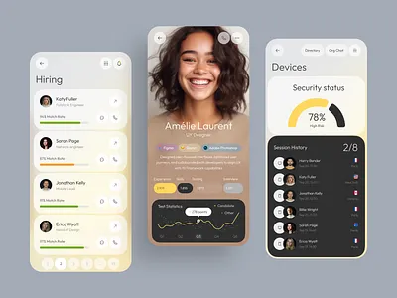

2. Usability (Ease of Use)
👉 Definition:
The product should be simple and straightforward, so users don’t need to spend too much time learning how to use it.
📝 Example:
Google’s search engine. Just one search bar and one button — no unnecessary complexity. That’s why everyone can use it easily.

Why It Matters
- Reduces frustration → users can accomplish tasks without confusion or struggle.
- Increases efficiency → simple, intuitive workflows save time and effort.
- Improves accessibility → clear design supports users of different abilities and experience levels.
- Encourages retention → people stick with products that feel easy and pleasant to use.
- Enhances business outcomes → higher usability leads to better adoption, conversions, and loyalty.
Screenshot:


3. Consistency
👉 Definition:
Every page and feature of the design should have the same look and feel. Colors, buttons, fonts, and navigation should be consistent and familiar.
📝 Example:
In Gmail, the same “Compose” button, navigation panel, and icons appear across all pages, so users don’t need to relearn the interface.

Why It Matters
- Builds familiarity → users quickly recognize patterns and know what to expect.
- Reduces the learning curve → consistent layouts, terms, and actions make systems easier to use.
- Prevents errors & confusion → predictable behavior helps users avoid mistakes.
- Strengthens brand identity → a unified design language reinforces trust and recognition.
- Improves efficiency → users spend less time figuring out how things work and more time achieving their goals.
Screenshot:
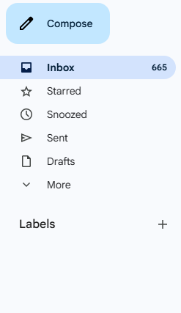

4. Feedback
👉 Definition:
The system should give instant feedback whenever a user takes action, so they know the system is responding.
📝 Example:
When you send a WhatsApp message, you get “single tick” (sent), “double tick” (delivered), and “blue tick” (seen) as feedback.

Why It Matters
- Provides reassurance → users know their actions have been registered.
- Prevents confusion & frustration → timely responses reduce uncertainty.
- Builds trust → users feel confident when systems communicate clearly.
- Improves task flow → clear feedback keeps users on track without hesitation.
- Enhances engagement → visual, auditory, or haptic cues make interactions feel lively and responsive.

5. Accessibility
👉 Definition:
Design should be usable by all types of users, including people with disabilities. Things like text size, color contrast, voice support, and screen readers matter.
📝 Example:
Websites that follow WCAG (Web Content Accessibility Guidelines) provide high color contrast, keyboard navigation, and screen reader compatibility.

Why It Matters:
- Promotes inclusivity → ensures people of all abilities can use the product.
- Expands reach → accessible design allows more users to engage with your product.
- Meets legal & ethical standards → many regions require digital accessibility compliance.
- Improves usability for everyone → clear navigation, captions, and readable text benefit all users, not just those with disabilities.
- Strengthens brand reputation → companies that prioritize accessibility are seen as responsible and user-focused.

Screenshot:
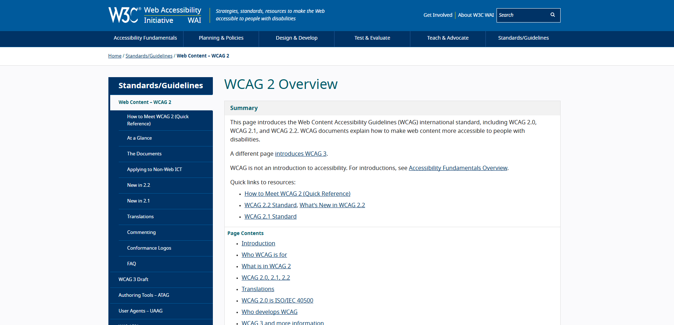

6. Hierarchy & Clarity
👉 Definition:
Important information should stand out first. The content should be structured and easy to read.
📝 Example:
On e-commerce sites like Amazon, the product name and price are the most prominent, while other details appear below.

Why It Matters
- Guides user attention → visual hierarchy helps users focus on what’s most important first.
- Reduces cognitive load → clear structure makes content easier to scan and understand.
- Improves navigation → users can find information and complete tasks without confusion.
- Enhances decision-making → prioritizing key actions makes choices simpler and faster.
- Strengthens overall usability → clarity ensures a seamless and frustration-free experience.
Screenshot:
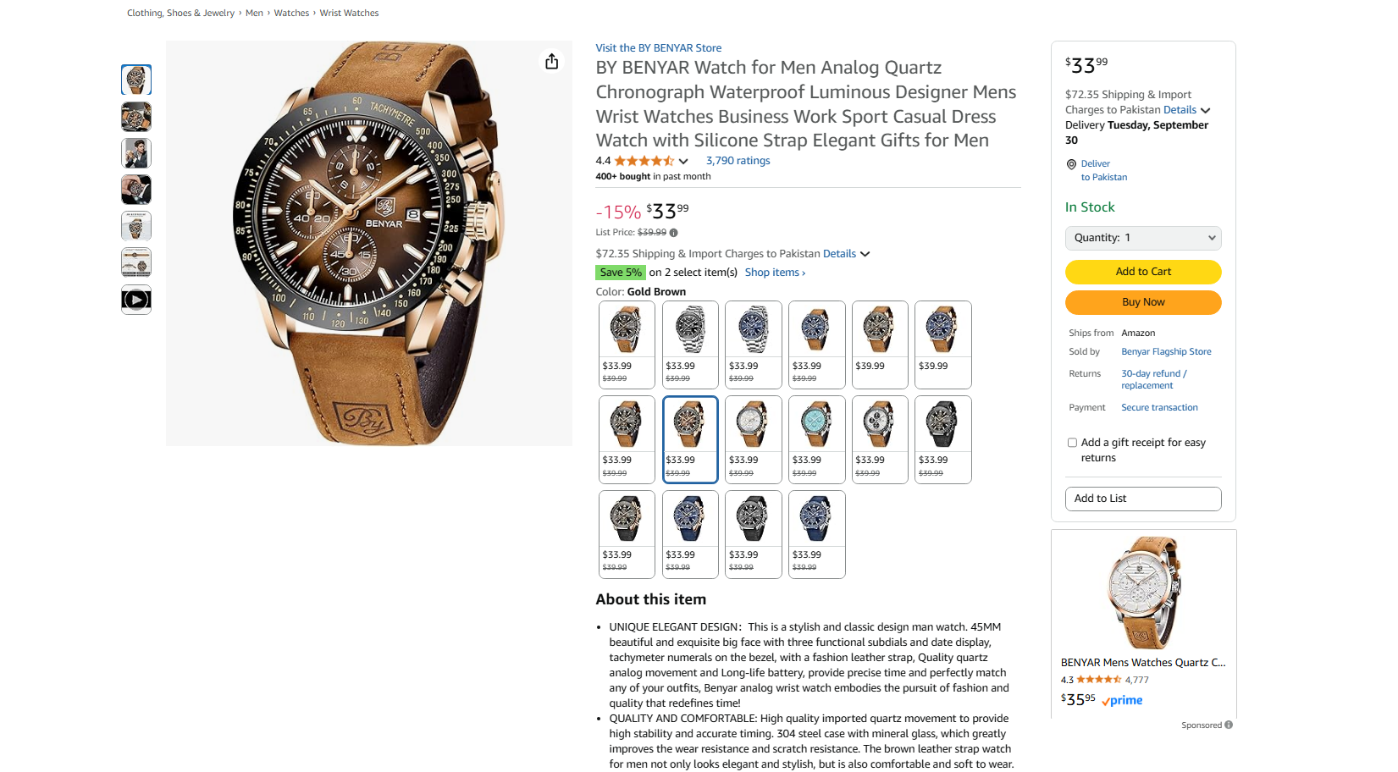

7. Efficiency
👉 Definition:
Users should be able to achieve their goals with minimum steps. Extra clicks or unnecessary steps should be avoided.
📝 Example:
Amazon’s “Buy Now” button takes you directly to checkout without adding to cart, which saves time.

Why It Matters
- Saves time and effort → users can complete tasks quickly with minimal steps.
- Boosts productivity → streamlined flows support frequent or complex actions.
- Reduces frustration → fewer obstacles mean smoother, stress-free interactions.
- Encourages repeat use → efficient systems keep users coming back.
- Improves business outcomes → faster, easier interactions lead to higher conversions and satisfaction.

Screenshot:
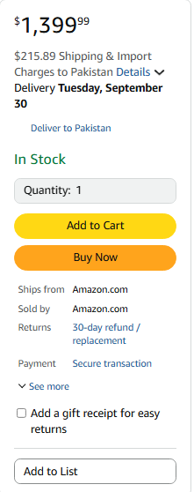

8. Satisfaction
👉 Definition:
In the end, users should feel happy and satisfied that the product solved their problem. This builds loyalty in the long run.
📝 Example:
Spotify — when a user easily searches, plays, and adds their favorite song to a playlist, they feel a positive and satisfying experience.

Why It Matters:
- Creates positive emotions → enjoyable interactions leave users feeling good about the product.
- Builds loyalty → satisfied users are more likely to return and keep using the product.
- Encourages word-of-mouth → happy users share their experiences, attracting new users.
- Reduces churn → when users enjoy the experience, they’re less likely to switch to competitors.
- Strengthens brand perception → satisfaction reinforces trust and long-term relationships.

Check Link: https://open.spotify.com/album/27wFxpV56Pg7Uxk0GxNfoF?highlight=spotify:track:7Csa4PStpuYIfUqNMKQ4V8
Please check the process according to Example

User-Centered Design

1. What is User-Centered Design?
👉 User-Centered Design (UCD) is a design approach that puts the user’s needs, goals, and feedback at the center of the product development process.
Instead of designing based only on business goals or assumptions, UCD ensures that the product is:
- Useful
- Usable
- Accessible
- Satisfying for the end user
📌 In short: Design with the user, for the user.

2. Key Characteristics of UCD
- Focuses on understanding users (their behaviors, needs, pain points)
- Iterative process → design, test, improve
- Involves users at every stage (research, prototyping, testing)
- Balances user needs with business goals

Why It Matters:

- Ensures relevance → products are built around real user needs, not assumptions.
- Reduces frustration & errors → designs match how people actually think and behave.
- Improves usability & accessibility → inclusive design supports a wider range of users.
- Boosts user satisfaction & loyalty → people return to products that truly solve their problems.
- Increases business value → fewer redesigns, higher adoption rates, and stronger competitive advantage.

Screenshot:

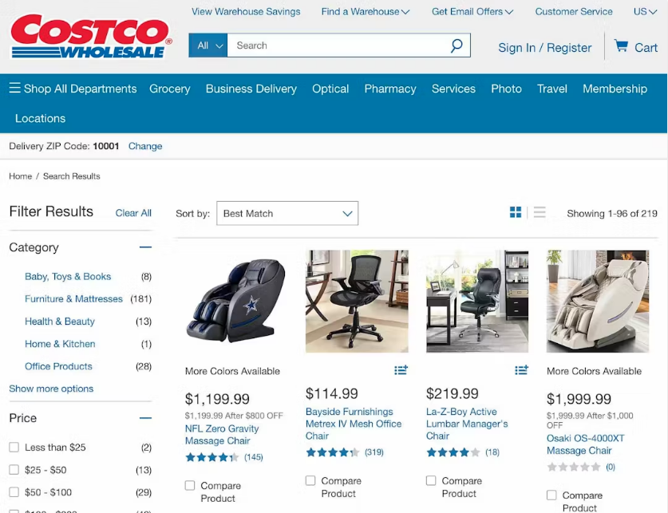

What is UI

1. What is UI?
👉 UI = User Interface
It refers to the visual and interactive elements of a digital product (website, mobile app, software) that users see and interact with.
📌 In simple words: UI is how the product looks and feels on the screen.

2. Elements of UI
A User Interface includes:
- Visual design: Colors, typography, icons, imagery
- Interactive components: Buttons, sliders, input fields, checkboxes, dropdowns
- Layout & spacing: Grids, alignment, padding, margins
- Navigation: Menus, tabs, search bars
- Micro-interactions: Hover effects, button animations, loading spinners

3. Example of UI

Food Delivery App:
- UI: The green "Order Now" button, food images, fonts, icons, navigation bar.
- UX: How easy it is to search for food, place an order, and track delivery.
👉 UI = What you see
👉 UX = How you feel while using it

5. Why is UI Important?
- Creates the first impression of the product
- Builds brand identity (consistent look & feel)
- Makes interaction intuitive and enjoyable
- Supports good UX (a beautiful interface that’s also easy to use)
Screenshot:

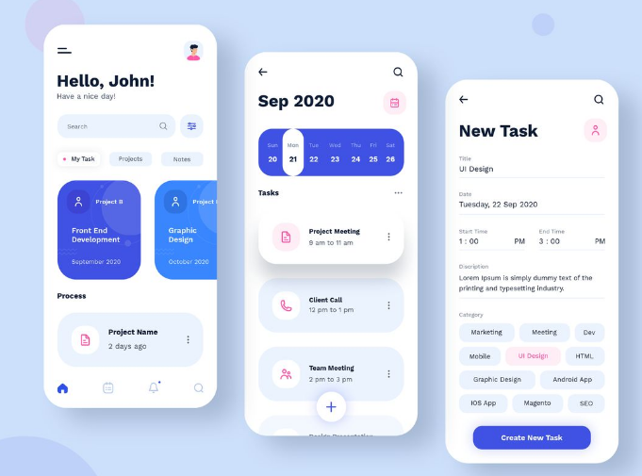

Principles of UI

🎨 Core Principles of UI Design (Detail + Example)

1. Clarity
👉 Definition:
The interface should clearly communicate information and actions. Users should never feel confused about what a button or feature does.
📝 Example:
On YouTube, the red Play button icon instantly tells users they can play a video. Clear icons and labels reduce confusion.

Why It Matters
- Prevents confusion → users instantly understand what elements mean and how to use them.
- Improves usability → clear labels, icons, and layouts make navigation effortless.
- Speeds up decision-making → users can act quickly when options are obvious.
- Reduces errors → clear UI elements minimize misclicks and wrong actions.
- Enhances trust & satisfaction → a clean, understandable interface feels professional and reliable.

Screenshot:


2. Consistency
👉 Definition:
Colors, typography, button styles, and layouts should be uniform throughout the product. Consistency makes the interface predictable and easier to use.
📝 Example:
In Gmail, the same “Compose” button, navigation panel, and icons appear across all pages, so users don’t need to relearn the interface.
Why It Matters
- Builds familiarity → users quickly recognize patterns and know how to interact.
- Reduces the learning curve → consistent layouts, colors, and components make navigation easier.
- Prevents confusion & mistakes → predictable behavior reduces errors.
- Strengthens brand identity → unified visuals and styles create a recognizable experience.
- Improves efficiency → users spend less time figuring out the interface and more time completing tasks.

Screenshot:


3. Familiarity
👉 Definition:
Use design patterns and elements that users already recognize from other platforms or real life. This reduces the learning curve.
📝 Example:
The shopping cart icon in e-commerce websites — everyone recognizes it means “view or buy products,” so no explanation is needed.

Why It Matters
- Speeds up learning → users rely on prior knowledge from similar apps or systems.
- Builds confidence → familiar patterns make users feel in control from the start.
- Reduces errors → users are less likely to make mistakes when interactions feel predictable.
- Improves efficiency → recognizable icons, layouts, and flows help users act faster.
- Enhances user satisfaction → familiarity creates comfort, making the interface feel natural.

Screenshot:

4. Visual Hierarchy
👉 Definition:
Arrange elements so that the most important information stands out first. Typography, colors, and spacing help guide the user’s eye.
📝 Example:
On Amazon product pages, the price and “Buy Now” button are big and bold, while product details are placed lower on the page.

Why It Matters
- Guides user attention → highlights the most important elements first.
- Improves scannability → users can quickly find what they need without overload.
- Enhances usability → clear prioritization makes navigation and decision-making easier.
- Reduces errors → proper hierarchy prevents users from overlooking critical actions.
- Strengthens aesthetics & trust → a well-structured interface feels professional and reliable.

Screenshot:


5. Feedback
👉 Definition:
The UI should provide immediate responses to user actions, so users know something has happened.
📝 Example:
When filling out an online form, if you miss a required field, the box turns red with an error message like “This field is required.”

Why It Matters
- Confirms user actions → reassures users that the system has registered their input.
- Prevents uncertainty → timely responses reduce confusion about what’s happening.
- Guides next steps → clear feedback helps users understand what to do next.
- Reduces errors & frustration → warnings, validations, or progress updates keep users on track.
- Enhances engagement → visual, auditory, or haptic cues make interactions feel responsive and dynamic.

6. Simplicity
👉 Definition:
Keep the interface minimal and avoid unnecessary elements. The focus should be on helping the user complete tasks quickly.
📝 Example:
Apple’s iOS design is known for its clean look, with lots of white space, simple icons, and no clutter.

Why It Matters
- Reduces cognitive load → users can focus on tasks without distraction.
- Improves usability → clear layouts and minimal elements make navigation easier.
- Speeds up decision-making → fewer choices help users act quickly and confidently.
- Prevents errors → a clean interface minimizes chances of clicking the wrong option.
- Enhances aesthetics & trust → simple, uncluttered UIs feel modern, professional, and reliable.
Screenshot:
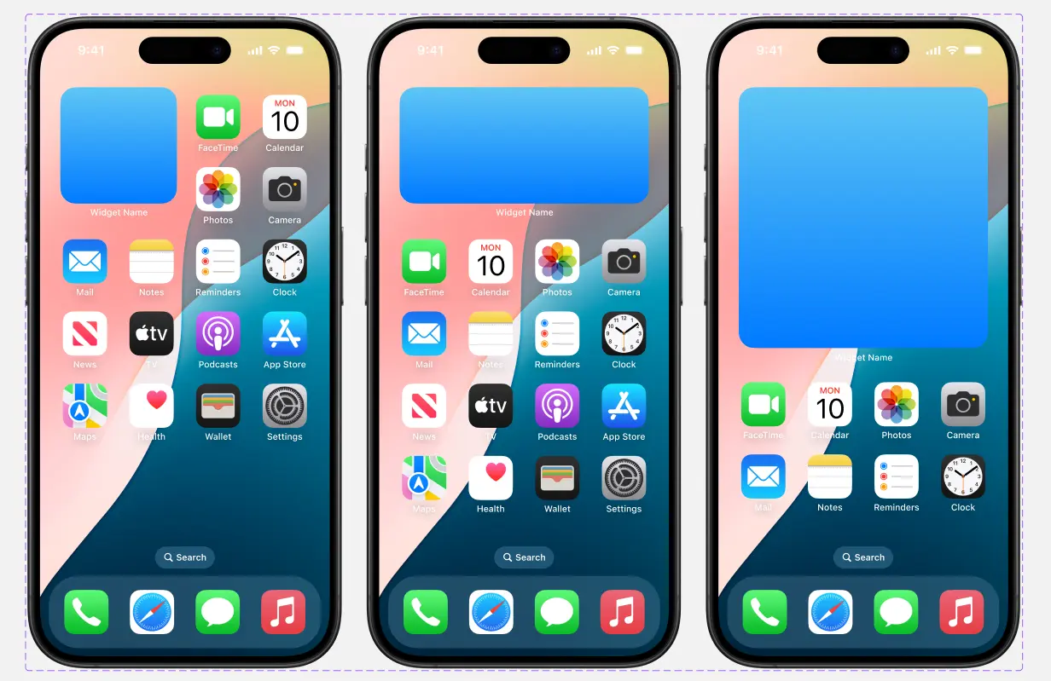

7. Accessibility
👉 Definition:
UI should be designed so that people with different abilities (visual, hearing, motor) can use it.
📝 Example:
Websites that follow WCAG (Web Content Accessibility Guidelines) provide high color contrast, keyboard navigation, and screen reader compatibility.

Why It Matters
- Promotes inclusivity → ensures people with disabilities can interact with the interface.
- Expands user reach → accessible designs allow more people to successfully use the product.
- Meets legal and ethical standards → compliance with accessibility guidelines avoids barriers and risks.
- Improves usability for all → features like readable text, captions, and proper contrast help everyone, not just users with impairments.
- Strengthens brand reputation → companies that prioritize accessibility are seen as responsible and user-focused.

Screenshot:


8. Affordance
👉 Definition:
UI elements should visually suggest how they can be used. A button should look like something clickable, and a slider should look draggable.
📝 Example:
Raised buttons with shadows on websites clearly show “this can be clicked.”

Why It Matters
- Makes functionality obvious → users can instantly see how elements should be used.
- Reduces confusion & hesitation → clear affordances guide users toward correct actions.
- Improves usability → intuitive controls allow users to interact without instructions.
- Prevents errors → when affordances are strong, users are less likely to misuse elements.
- Enhances efficiency & satisfaction → obvious cues create smoother, faster interactions.

9. Flexibility
👉 Definition:
The interface should allow both beginners and advanced users to use it comfortably.
📝 Example:
MS Word provides menus for beginners but also keyboard shortcuts for advanced users who want to work faster.

Why It Matters
- Supports different user needs → offers multiple ways to complete tasks (e.g., mouse, touch, keyboard).
- Enhances efficiency → shortcuts and advanced options speed up frequent actions for power users.
- Increases accessibility → adaptable interfaces work better for users with different abilities.
- Encourages personalization → flexible settings let users tailor the UI to their preferences.
- Improves long-term engagement → as users grow more skilled, flexibility keeps the experience effective and satisfying.

10. Error Prevention & Recovery
👉 Definition:
Good UI minimizes user mistakes and helps them recover easily if they happen.
📝 Example:
When you delete a file in Windows, it first goes to the Recycle Bin, giving you a chance to restore it if it was deleted accidentally.

UI vs UX

3. Difference Between UI and UX
Aspect | UI (User Interface) | UX (User Experience)
Definition | Visual elements the user interacts with | The overall journey of the user
Focus | Look & feel (aesthetic) | Ease of use & satisfaction
Elements | Colors, fonts, buttons, layouts, icons | Research, flows, usability, testing
Goal | Make the product visually appealing | Make the product useful & usable
When it happens | During design phase (mockups, prototypes) | Throughout the process (research → design → testing → iteration)
Deliverables | Style guide, design system, screen designs | Personas, wireframes, user flows, test reports
Analogy | UI = Car’s steering wheel, seats, dashboard (appearance) | UX = Driving experience (comfort, speed, ease of control)

Typography

1. What is Typography?
👉 Typography is the art and technique of arranging text so that it is readable, clear, and visually appealing.
It includes:
- Choosing typefaces (fonts)
- Setting font size, weight, spacing, and alignment
- Creating a visual hierarchy with text
📌 In short: Typography is about how text looks and how it communicates meaning.

2. Why Typography is Important?
- Readability → Makes text easy to read.
- Hierarchy → Highlights important content (headings vs body).
- Brand Identity → Fonts reflect personality (formal, playful, modern).
- User Experience → Clear typography improves usability.

3. Elements of Typography

🔹 1. Typeface vs Font
- Typeface = A family of fonts (e.g., Roboto).
- Font = A specific style/weight within a typeface (e.g., Roboto Bold 16px).

🔹 2. Font Size
- Defines the size of the text.
- Example: Headings (24–32px), Body text (14–16px).

🔹 3. Font Weight
- Thickness of letters.
- Example: Light, Regular, Bold, Extra Bold.

🔹 4. Line Spacing (Leading)
- Space between lines of text.
- Too little = crowded, too much = disconnected.

🔹 5. Letter Spacing (Tracking)
- Space between letters in a word.

🔹 6. Hierarchy
- Using size, weight, and style to show importance.
- Example:
  - Heading (big, bold)
  - Subheading (medium)
  - Body text (small, regular)

🔹 7. Alignment
- Left, Right, Center, or Justified.
- Left alignment = most common in digital products.

🔹 8. Contrast
- Using different fonts, sizes, and colors to differentiate content.

5. Example in a Mobile App
Food Delivery App:
- App Title: Bold Sans Serif (24px)
- Food Category: Medium weight, 18px
- Food Description: Regular, 14px, gray
- Price: Bold, 16px, highlighted color
Typography ensures the user instantly knows → title, description, price.

Screenshot:
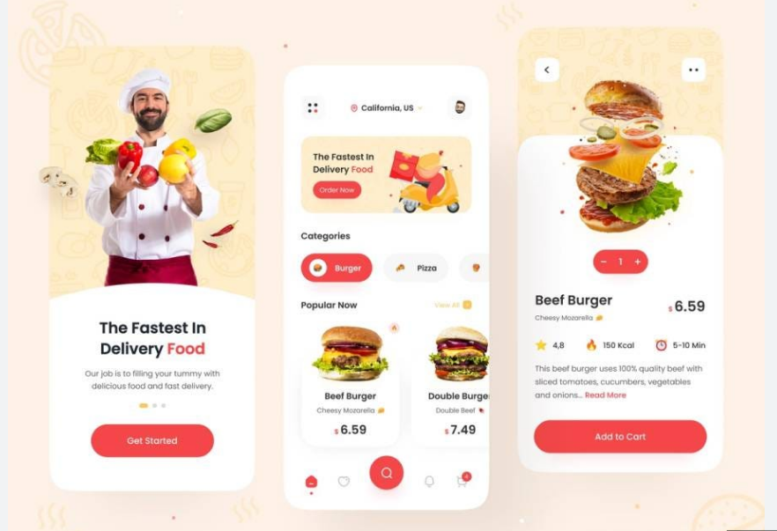

Colors

Color Theory

1. What is Color Theory?
👉 Color Theory is the study of how colors work together, how they affect emotions, and how they can be combined to create visually appealing and meaningful designs.
📌 It helps designers use colors effectively for aesthetics, branding, and usability.

2. The Color Wheel 🎨
The Color Wheel is the foundation of color theory. It’s a circular diagram showing how colors relate to each other.
- Primary Colors: Red, Blue, Yellow (cannot be made by mixing other colors).
- Secondary Colors: Green, Orange, Purple (made by mixing primary colors).
- Tertiary Colors: Mix of primary + secondary (e.g., Blue-Green, Red-Orange).

Why It Matters
- Guides user attention → highlights important actions or information.
- Builds visual hierarchy → colors help differentiate primary, secondary, and background elements.
- Evokes emotions & moods → colors influence how users feel about the product.
- Strengthens brand identity → consistent color usage reinforces recognition and trust.
- Supports accessibility → proper contrast and color choices ensure readability for all users.

3. Color Schemes (Combinations)
Designers use different color harmonies to create balance:
- Monochromatic → Variations of one color (light → dark).
  - Example: Light Blue, Medium Blue, Dark Blue.
  - Clean, minimal look.
- Analogous → Colors next to each other on the wheel.
  - Example: Blue + Green + Teal.
  - Natural and calming.
- Complementary → Opposite colors on the wheel.
  - Example: Blue + Orange, Red + Green.
  - High contrast, eye-catching.
- Split-Complementary → A base color + two colors next to its opposite.
  - Example: Blue + Yellow-Orange + Red-Orange.
  - Balanced but still vibrant.
- Triadic → 3 colors evenly spaced on the wheel.
  - Example: Red + Yellow + Blue.
  - Playful, strong contrast.
- Tetradic (Double Complementary) → 2 complementary pairs.
  - Example: Blue + Orange + Green + Red.
  - Rich, but tricky to balance.

4. Color Properties
- Hue → The base color (red, green, blue).
- Saturation → Intensity of color (dull → vibrant).
- Value (Brightness) → Lightness or darkness of a color.

5. Psychology of Colors (Emotional Impact)
Colors influence emotions and behavior.
- 🔴 Red → Energy, urgency, danger (e.g., error messages, sale banners).
- 🔵 Blue → Trust, calm, professionalism (e.g., banking, healthcare apps).
- 🟢 Green → Growth, success, nature (e.g., finance, eco-friendly apps).
- 🟡 Yellow → Optimism, attention-grabbing (e.g., warning messages).
- 🟣 Purple → Luxury, creativity (e.g., beauty brands).
- ⚫ Black → Power, elegance (e.g., premium products).
- ⚪ White → Simplicity, cleanliness (e.g., minimal apps).

6. Colors in UI/UX Design
- Primary Colors → Main brand identity (e.g., Facebook = Blue).
- Secondary Colors → Used for highlights, accents.
- Neutral Colors → Backgrounds, text (white, gray, black).
- Semantic Colors → Meaning-based (e.g., Green = success, Red = error, Yellow = warning).
Example in a Banking App:
- Primary → Blue (trust & reliability)
- Success → Green (transaction successful)
- Error → Red (transaction failed)
- Warning → Yellow (low balance)
Screenshot: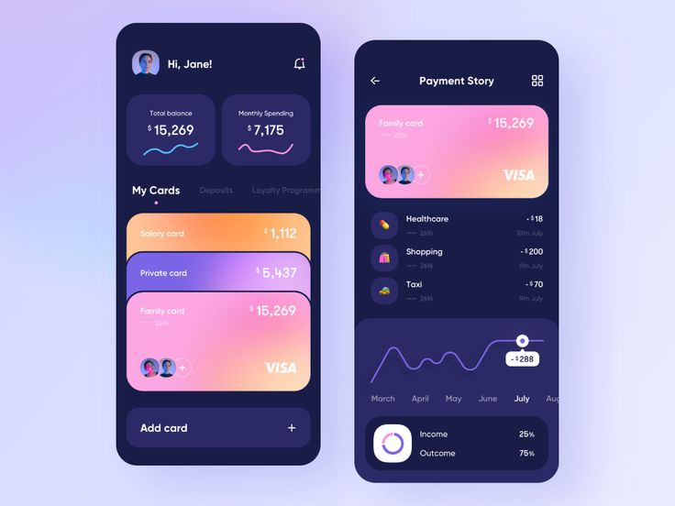
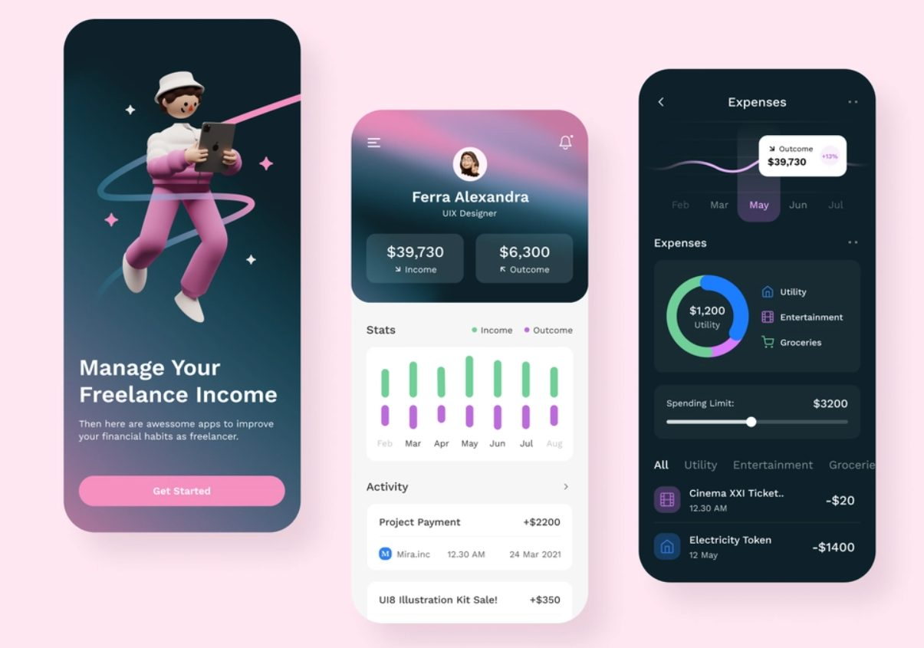

60-30-10 Rule

1. What is the 60-30-10 Color Rule?
👉 It’s a design rule for creating balanced, harmonious, and visually pleasing color palettes.
- 60% → Dominant Color (main color, background, large areas)
- 30% → Secondary Color (supports the dominant color, used in smaller areas)
- 10% → Accent Color (used for emphasis, highlights, buttons, CTAs)
📌 This rule keeps designs simple, avoids clutter, and ensures focus.

2. Breakdown of the Rule
- 60% (Dominant Color):
  - Creates the overall "base" of the design.
  - Example: White, light gray, or soft blue background.
- 30% (Secondary Color):
  - Provides contrast, adds interest.
  - Example: Navy blue for navigation bars or side panels.
- 10% (Accent Color):
  - Draws attention to important elements.
  - Example: Bright orange for buttons, links, or icons.

3. Example in UI Design

🌐 Website Example
- 60% → White background
- 30% → Dark Blue for sections and text
- 10% → Orange for buttons (CTA: "Sign Up")

📱 Mobile App Example (Food Delivery)
- 60% → Light Gray background
- 30% → Green for headers & navigation
- 10% → Red for “Add to Cart” button

4. Why is it Important?
- Creates visual balance → prevents interfaces from looking cluttered or chaotic.
- Establishes hierarchy → users can instantly distinguish primary, secondary, and accent elements.
- Enhances aesthetics → the color ratio makes designs look polished and professional.
- Guides user focus → accent colors naturally draw attention to key actions (like CTAs).
- Strengthens brand consistency → applying a clear color scheme reinforces recognition.

Screenshot:



Spacing

1. What is Spacing in Design?
👉 Spacing refers to the empty space (white space) between and around elements in a design.
It includes:
- Space between letters, words, and lines (typography).
- Space between buttons, images, cards, sections (layout).
- Margins, padding, and overall negative space.
📌 In short: Spacing = breathing room in design.

2. Why Spacing is Important?
- Improves readability → adequate spacing makes text and elements easier to scan.
- Enhances visual hierarchy → spacing helps separate and group related content.
- Reduces cognitive load → clean layouts prevent users from feeling overwhelmed.
- Increases click accuracy → proper spacing between interactive elements reduces errors.
- Strengthens aesthetics & professionalism → well-spaced designs feel modern, balanced, and trustworthy.

3. Types of Spacing

🔹 1. Letter Spacing (Tracking)
- Space between letters.
- Example:
  - T h i s i s t o o w i d e (too much spacing).
  - This is just right (balanced).

🔹 2. Line Spacing (Leading)
- Space between lines of text.
- Example: Headlines need tighter spacing, paragraphs need more.

🔹 3. Paragraph Spacing
- Space before and after a block of text.
- Helps separate different sections.

🔹 4. Element Spacing
- Padding inside a component (space between text and button border).
- Margin between components (space between two cards, sections).

🔹 5. White Space (Negative Space)
- The "empty" area with no content.
- Example: Google homepage uses white space to draw focus on the search bar.

4. Examples in UI

Example 1: Login Screen
- Good Spacing:
  - Labels and input fields close together.
  - Enough padding inside input boxes.
  - “Login” button separated by proper margin.

Screenshot:
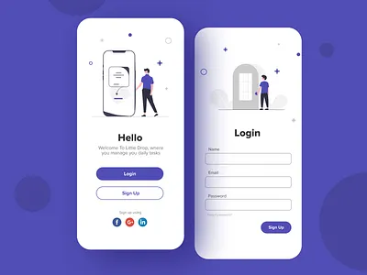
- Bad Spacing:
  - Labels far away from fields → confusion.
  - Elements cramped with no breathing room.

Screenshot:
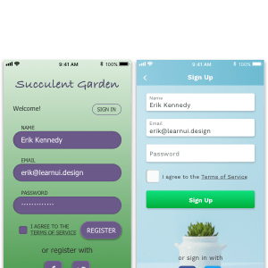

White or Negative Spacing

1. What is White Space (Negative Space)?
👉 White Space (also called Negative Space) is the empty area between and around design elements (text, images, buttons, sections).
📌 It doesn’t have to be literally white — it can be any background color (black, gray, blue, etc.).
The purpose is to give breathing room and improve clarity.

3. Why White Space is Important?
- Improves readability & focus → empty space helps users concentrate on key content.
- Creates visual balance → prevents clutter and makes layouts feel organized.
- Enhances hierarchy → separates sections and highlights important elements.
- Boosts aesthetics → clean, spacious designs feel modern and professional.
- Reduces cognitive load → white space gives users’ eyes and minds room to breathe.

4. Examples in UI

Example 1: Google Homepage
- Lots of empty space → search bar is the main focus.
- Minimal distractions → users know exactly what to do.

Example 2: Login Screen
- Good White Space:
  - Labels close to their input fields.
  - Adequate space between “Email,” “Password,” and “Login” button.
- Bad White Space:
  - Everything cramped together → hard to read and interact with.
Screenshot:
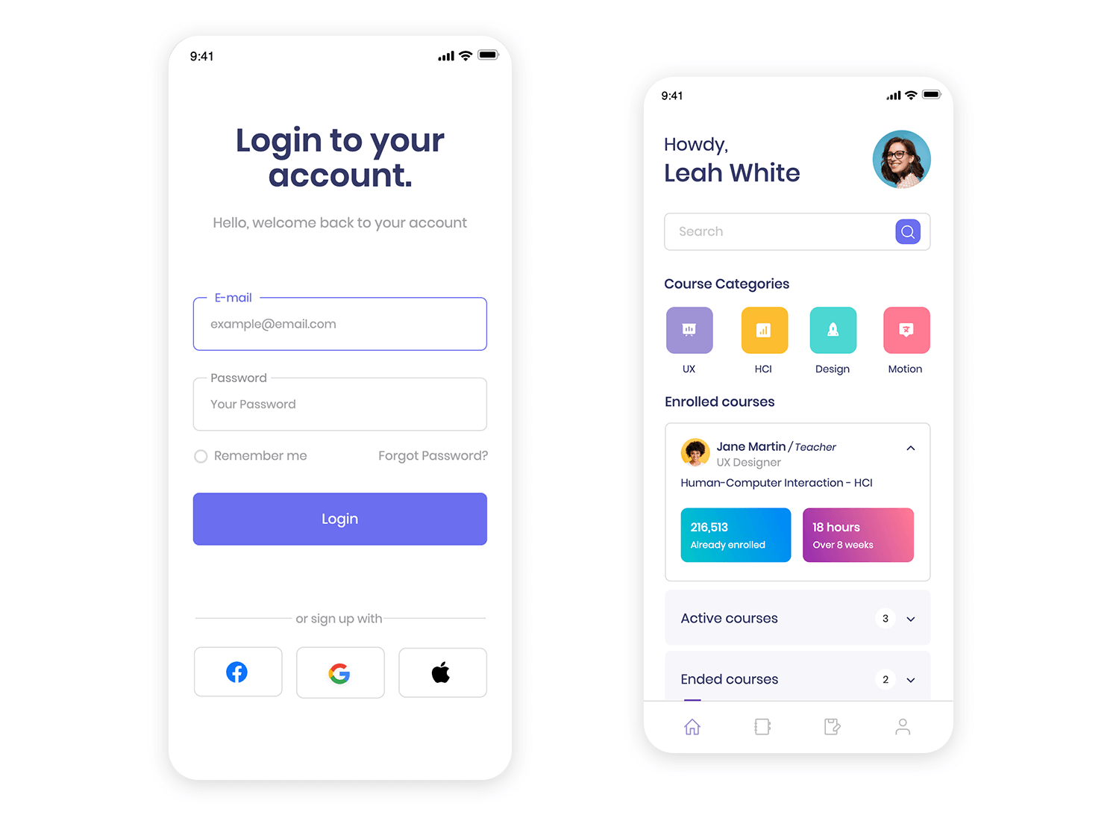

Contrast

1. What is Contrast?
👉 Contrast in design is the difference between two or more elements so that they stand out from each other.
It helps guide the user’s eye, improve readability, and highlight important information.
📌 In short: Contrast makes key elements noticeable.

2. Types of Contrast in Design
- Color Contrast 🎨
  - Using light vs dark or opposite colors.
  - Example: White text on a black button.
- Size Contrast 🔠
  - Making important elements larger than others.
  - Example: A big headline vs small body text.
- Weight Contrast ✍️
  - Using bold vs regular text.
  - Example: Product Name (bold) vs description (regular).
- Shape Contrast ⬛⚪
  - Different shapes to draw attention.
  - Example: A round “Call to Action” button among rectangular inputs.
- Position Contrast ↔️
  - Placing key elements in standout positions.
  - Example: Center-aligned CTA button.
- Texture & Style Contrast
  - Using different patterns, shadows, or font styles.
  - Example: Flat icons vs 3D styled icons.

3. Why It Matters
- Enhances readability → strong contrast between text and background ensures clarity.
- Guides user attention → contrast highlights important elements like buttons or alerts.
- Improves visual hierarchy → differentiates primary actions from secondary content.
- Supports accessibility → sufficient contrast helps users with visual impairments.
- Strengthens aesthetics → well-balanced contrast makes the interface visually engaging.

4. Examples

Example 1: Login Screen
- Good Contrast: Dark blue "Login" button with white text.
- Bad Contrast: Light gray button with white text (hard to see).
Screenshot:


Alignment

1. What is Alignment?
👉 Alignment is the arrangement of elements (text, images, buttons, etc.) along a common line, grid, or edge to create order, balance, and visual connection.
📌 In short: Alignment makes a design look organized and professional instead of messy.

2. Why Alignment Matters?
- Creates visual order → aligned elements make the layout look clean and organized.
- Improves scannability → users can easily follow content when it’s structured consistently.
- Enhances readability → proper text alignment supports smoother reading experiences.
- Builds professional aesthetics → aligned interfaces feel polished and trustworthy.
- Strengthens usability → consistent alignment reduces confusion and helps users focus on tasks.

3. Types of Alignment

🔹 1. Left Alignment
- Most common in UI and text.
- Easy for the eye to follow (natural reading flow).
- Example: Articles, forms, app menus.

🔹 2. Right Alignment
- Less common, used for special emphasis.
- Works well with numbers or design balance.
- Example: Price lists, chat bubbles.

🔹 3. Center Alignment
- Good for headings, short text, or symmetry.
- Not great for long paragraphs (hard to read).
- Example: Splash screens, titles.

🔹 4. Justified Alignment
- Text stretched to align both left & right edges.
- Looks neat in print, but can create awkward spacing on digital screens.
- Example: Newspapers, e-books.

🔹 5. Grid Alignment (UI/UX)
- Placing elements according to a grid system.
- Ensures consistent spacing & balance.
- Example: Card layouts (Netflix, Pinterest, e-commerce apps).

4. Examples in UI

Example 1: Login Screen
- Good Alignment:
  - Input fields, labels, and buttons aligned to the left.
  - “Login” button centered below for balance.
Screenshot:

- Bad Alignment:
  - Fields scattered at different positions = looks messy, harder to use.
Screenshot:


Proximity in design

1. What is Proximity in Design?
👉 Proximity is a design principle that means grouping related elements together and keeping unrelated elements separate.
📌 In short: If things belong together, place them close. If they don’t, keep them apart.
This helps users quickly understand relationships between information.

2. Why Proximity is Important?
- Establishes relationships → groups related elements together so users understand connections.
- Improves scannability → proximity helps users quickly find and process information.
- Reduces clutter → clear grouping prevents the interface from feeling overwhelming.
- Enhances visual hierarchy → distance between elements signals importance and structure.
- Strengthens usability → logical grouping makes navigation and interaction more intuitive.

3. Examples of Proximity

Example 1: Login Form
- Good Proximity:
  - Label (“Email”) is directly above the email input field.
  - “Login” button close to fields.
- Bad Proximity:
  - Labels far from input fields → user gets confused about which label belongs where.

Example 2: E-commerce Product Card
- Good Proximity:
  - Product image, title, price, and “Add to Cart” button grouped together.
- Bad Proximity:
  - Price on the far right, “Add to Cart” button at the bottom → feels disconnected.

Example 3: Website Navigation
- Good Proximity: Related menu items grouped together (Home, About, Services).
Screenshot:
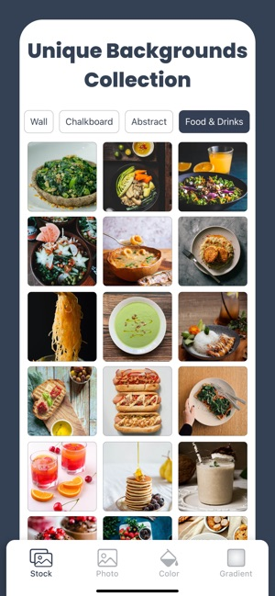
- Bad Proximity: Scattered links with no grouping → looks messy.
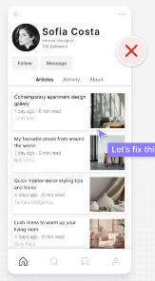

Repetition in Design

1. What is Repetition in Design?
👉 Repetition is the design principle of reusing the same elements consistently throughout a product.
It creates unity, consistency, and brand identity.
📌 In short: Repetition = keeping things consistent so users feel familiar.

2. Why Repetition is Important?
- Builds consistency → repeated styles, colors, and patterns create a unified look.
- Strengthens brand identity → repetition of visual elements reinforces recognition.
- Improves usability → consistent interactions help users predict how things work.
- Enhances visual rhythm → repeated elements guide the eye smoothly through the layout.
- Reduces cognitive load → familiar patterns minimize the effort needed to learn the interface.

3. Examples of Repetition in UI/UX

Example 1: Buttons
- Good Repetition: All CTA buttons use the same color, shape, and hover effect.
Screenshot:
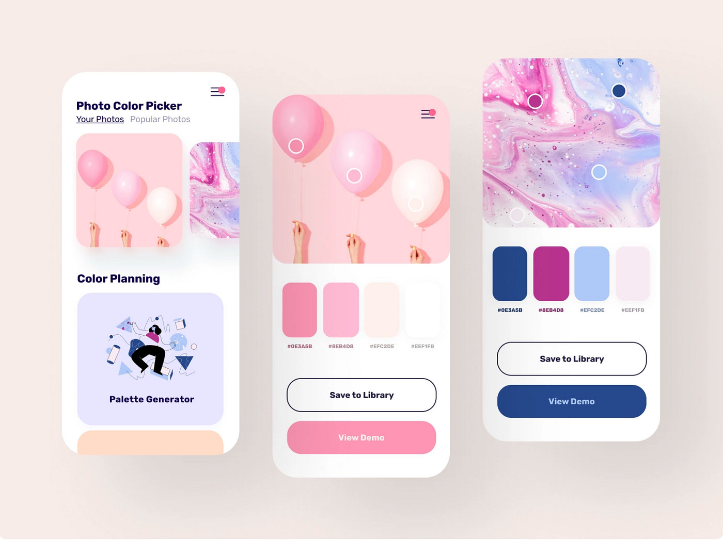
- Bad Repetition: “Buy Now” button is blue on one page, green on another, and red elsewhere → confuses users.
Screenshot:
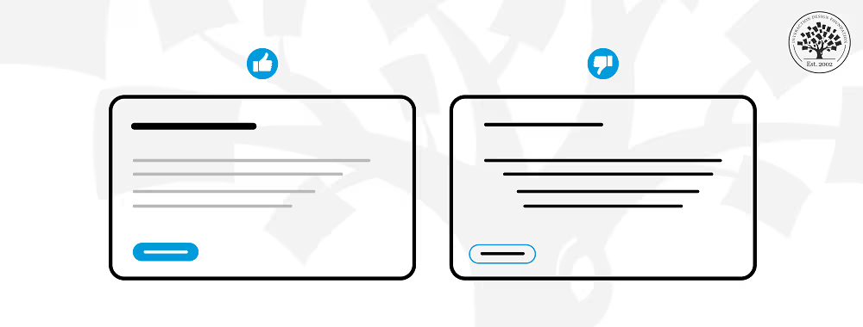

Wireframing & User flow

Wireframes & User Flow Diagrame

1. What is Wireframing?
👉 Wireframing is like a blueprint of a website or mobile app.
- It shows the basic structure, layout, and elements of the design.
- It does not focus on colors, images, or final styling.
- Purpose: to decide "where things will go, how users will navigate, and how the content is structured."
📌 Think of it as the skeleton of a house before painting and decoration.
Example:
For a Food Delivery App wireframe, you may only see:
- A box at the top for a search bar
- Square boxes for food categories
- A simple bottom bar with Home, Cart, and Profile buttons
- No images or fancy styling, just placeholders

Why It Matters
- Provides early visualization → helps stakeholders see the layout before investing in design details.
- Saves time & cost → identifies problems early, reducing expensive redesigns later.
- Improves clarity & communication → aligns designers, developers, and clients on structure and flow.
- Focuses on usability → highlights navigation, hierarchy, and user journeys without distractions.
- Supports iteration → makes it easy to test and refine ideas quickly.

2. Low Fidelity vs High Fidelity Wireframing

🔹 Low Fidelity Wireframe (Lo-Fi)
- Very simple and basic.
- Uses boxes, lines, and placeholders.
- No colors, fonts, or images.
- Main purpose → Quickly visualize an idea.
Example (Lo-Fi Food App):
- A rectangle box for the search bar
- Plain square boxes representing food items
- A placeholder button labeled "Add to Cart"
Screenshot:
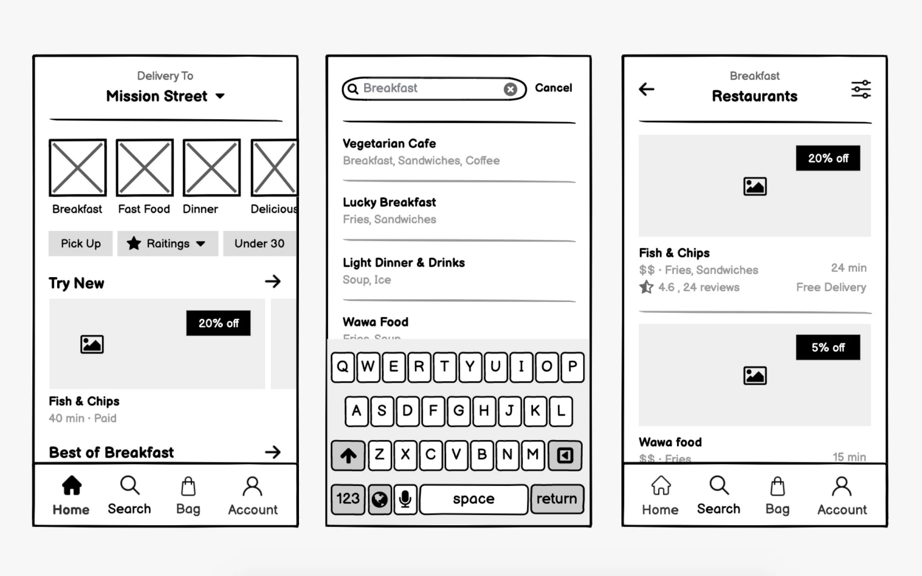

🔹 High Fidelity Wireframe (Hi-Fi)
- Detailed and close to the final product.
- Includes real images, icons, fonts, spacing, and colors.
- Looks more like an actual prototype.
- Main purpose → For client presentations and usability testing.
Example (Hi-Fi Food App):
- A real search bar with rounded edges + search icon
- Food item images (pizza, burger, etc.)
- A styled button with color (e.g., green “Add to Cart”)
- Bottom navigation bar with real icons
Screenshot:
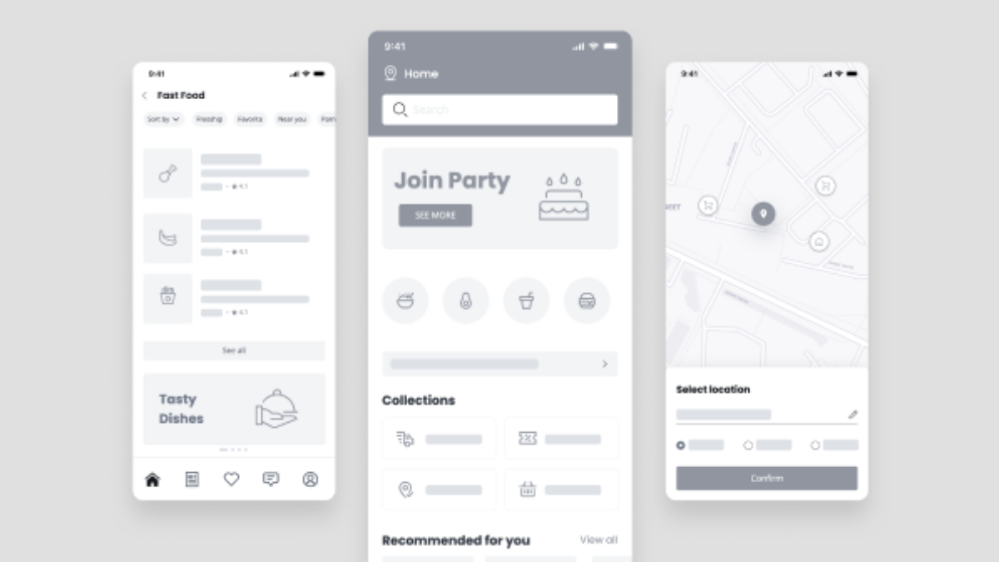
📌 Difference in one line:
- Lo-Fi = Skeleton (structure only)
- Hi-Fi = Skin + Design (looks like the final product)

3. What is a User Flow Diagram?
👉 A User Flow Diagram is a visual map of the user’s journey in an app/website.
It shows:
- Where the user starts (entry point)
- What steps they follow
- Where they achieve their goal (exit point)

Why It Matters:
- Provides clear visualization → maps out how users move through a product step by step.
- Identifies pain points → highlights areas where users might get stuck or confused.
- Improves usability → ensures tasks can be completed with minimal friction.
- Enhances team alignment → gives designers, developers, and stakeholders a shared understanding of the journey.
- Supports optimization → makes it easier to streamline processes and remove unnecessary steps.

Screenshot:

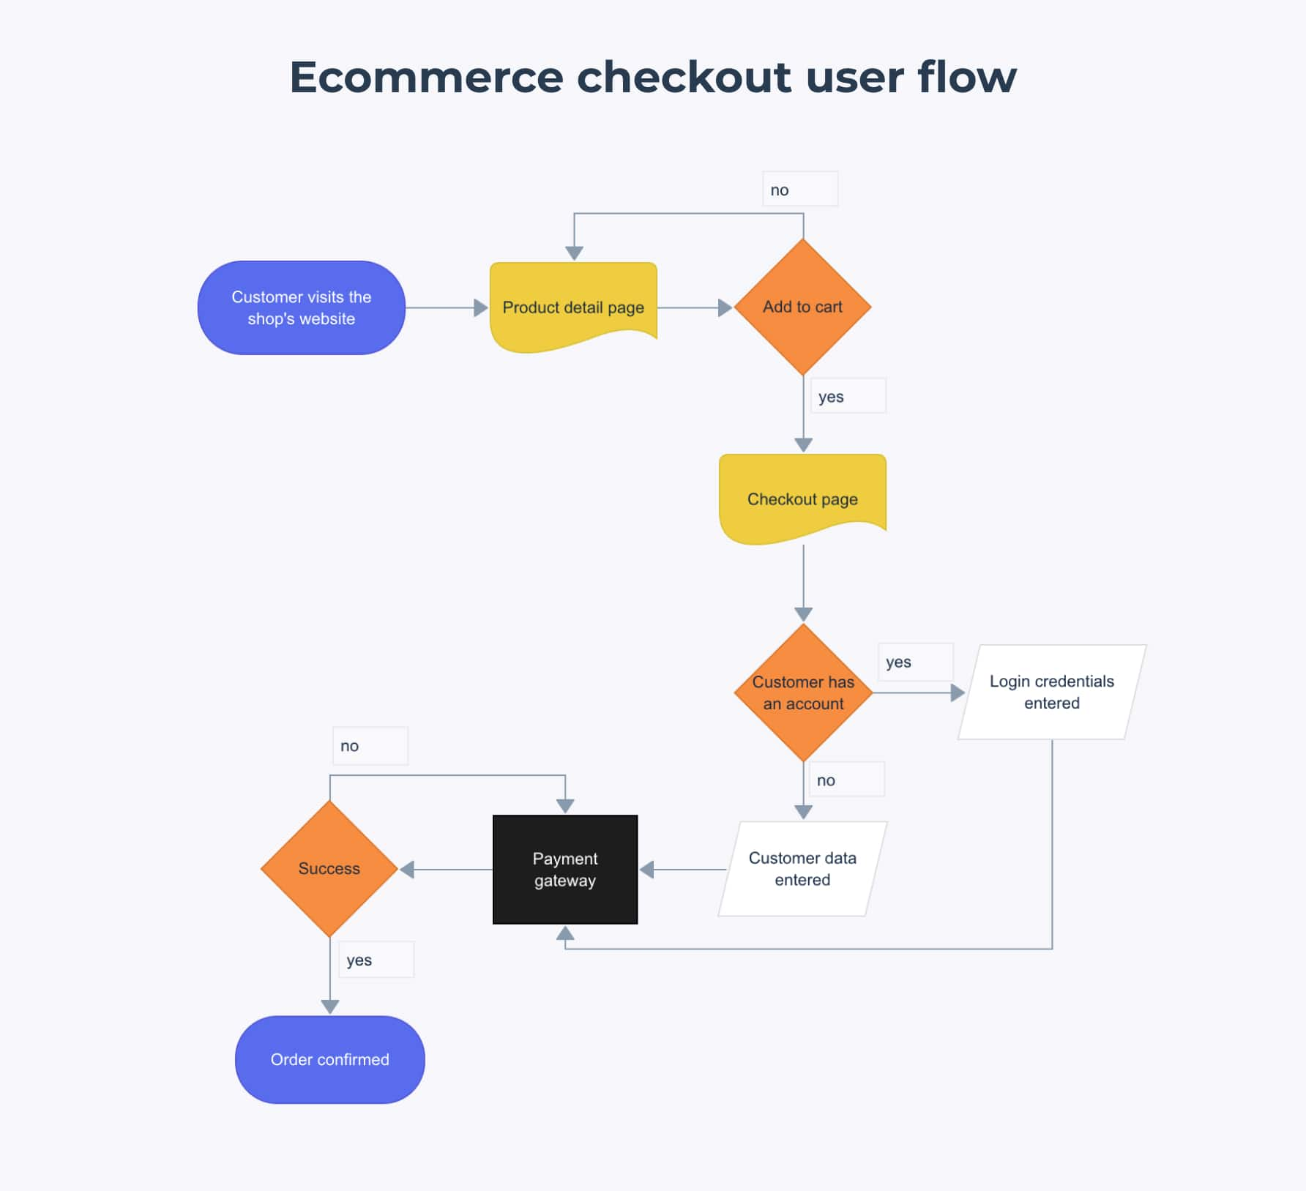

Prototyping

1. What is Prototyping?
👉 Prototyping is the process of creating an early model (mock-up) of a product to test how it will look, feel, and work before the final version is developed.
It helps:
- Visualize the product flow
- Test usability with users
- Communicate ideas with stakeholders & developers
- Reduce risks and save time
📌 Think of it as making a “sample version” of an app/website before investing in full development.
Example:
If you are building a Ride Booking App, instead of coding it directly, you first make a prototype where users can:
- See the booking screen
- Choose pickup & drop
- Simulate the booking flow (but not actually book a ride yet)

2. Why It Matters
- Brings ideas to life → turns concepts into interactive models for better understanding.
- Supports early testing → allows teams to validate usability and functionality before development.
- Saves time & cost → catches design flaws early, avoiding expensive fixes later.
- Improves collaboration → helps designers, developers, and stakeholders align on vision.
- Enhances user feedback → users can interact with prototypes and provide real insights.

3. Types of Prototyping
There are different ways to prototype depending on goals and resources:

🔹 1. Paper Prototyping
- Drawn on paper with sketches.
- Fastest and cheapest.
- Good for brainstorming.
Example: Sketching login screen + home screen on paper.
Screenshot:
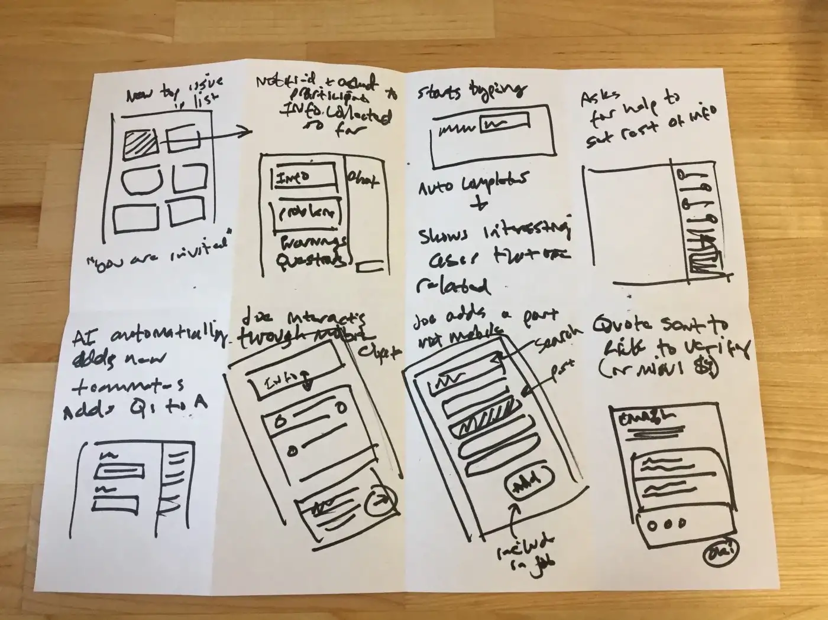

🔹 3. Low-Fidelity Digital Prototype
- Made using simple wireframing tools (like Balsamiq, Figma Lo-Fi mode).
- Shows layout and flow, but not details.
Example: Clickable wireframe of an e-commerce app where buttons just link to the next screen (no real data).
Click Link: https://www.figma.com/design/SVa98oiJ4KtaqKXgTalnUt/Ecommerce-website-Low-fidelity-prototypes--Community-?node-id=0-1&p=f&t=9k9V6f7JfexjGucP-0

Screenshot:

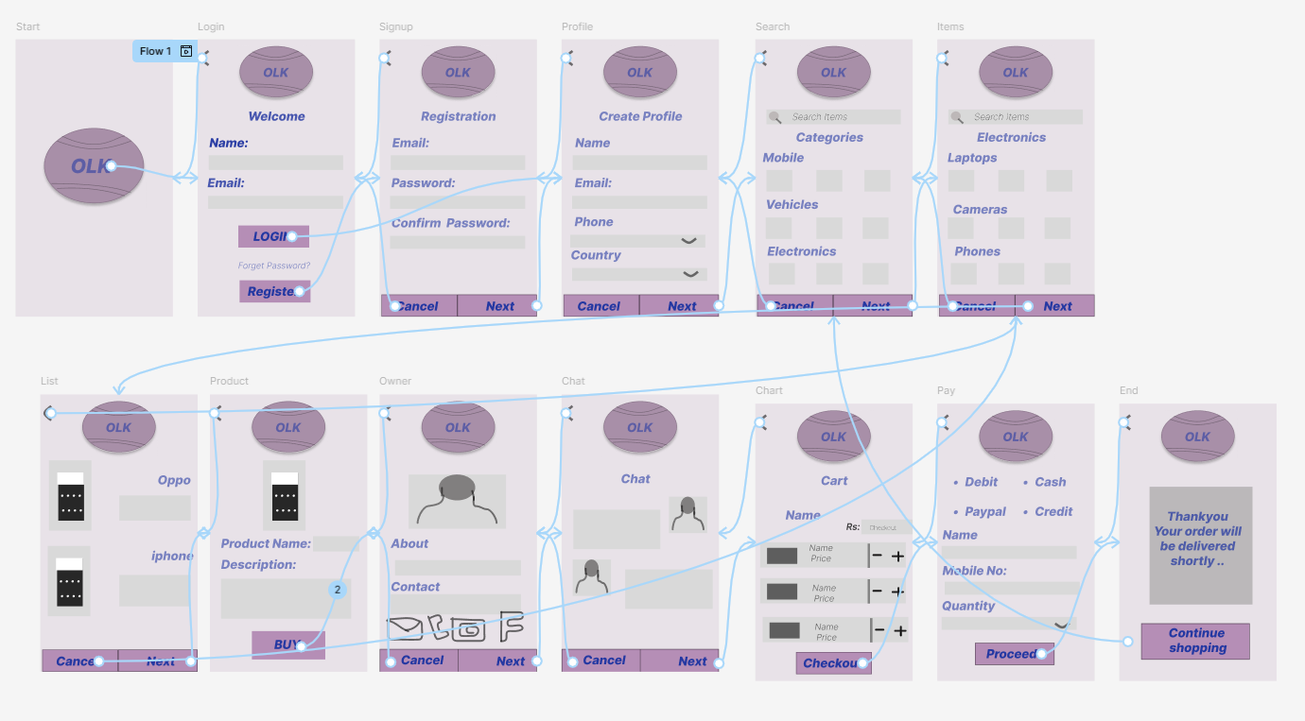

🔹 3. High-Fidelity Digital Prototype
- Looks and behaves close to the final product.
- Includes visuals, colors, fonts, and interactions.
- Useful for usability testing and client demos.
Example: In Figma/Adobe XD, a food delivery app prototype with real images, navigation, and animations.
Check Link: https://www.figma.com/design/v4gqDciLPKTdNojpW59a2G/Food-delivery-APP--Community-?node-id=0-1&p=f&t=fBWiV7SoNXWxevGn-0
Screenshot:
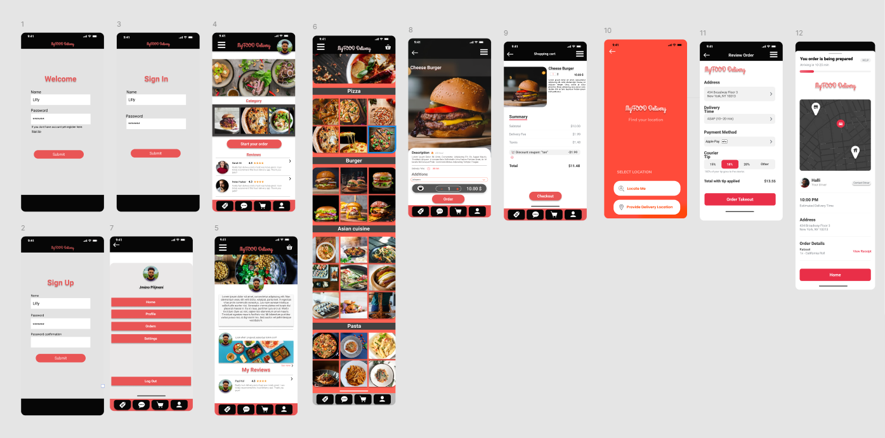

🔹 4. Functional Prototype
- Contains partial or full real functionality.
- Sometimes built using actual code.
- Expensive and time-consuming but gives the most realistic test.
Example: A test version of an app where you can actually place a test order and see results.

4. Prototype Fidelity
👉 Fidelity = the level of detail & realism in a prototype.
- Low Fidelity (Lo-Fi) → Basic sketches or wireframes (structure only).
- Medium Fidelity → Some visuals, grayscale UI, limited interaction.
- High Fidelity (Hi-Fi) → Final visuals, colors, typography, clickable and interactive.
📌 Think:
- Lo-Fi = Skeleton
- Mid-Fi = Skeleton + rough skin
- Hi-Fi = Realistic model

5. Micro-Interaction Prototype
👉 Micro-interactions are small interactive moments in an app/website that make the experience smooth and engaging.
- They provide feedback, improve usability, and delight users.
Examples of Micro-Interactions:
- The “Like” button animation on Instagram (❤️ expands when tapped).
- A loading spinner showing progress.
- Button color changing when hovered.
- Notification bell shaking when you get an alert.
📌 A Micro-Interaction Prototype is when you design & test these small animations in tools like Figma, Principle, or After Effects before adding them into the real app.
Check Link: https://www.figma.com/design/JogLJepNvzOKIyFcX65GUL/Micro-interactions?node-id=859-2295&t=a3aTvDzN0rCPrJG8-0

Usability Testing

🔹 What is Usability Testing?
Usability Testing is a user-centered evaluation method in which a product (like a website, mobile app, software, or device) is tested by real users to check:
- Is the product easy to understand and use?
- Can users achieve their goals efficiently?
- Do users face confusion, errors, or frustration?
The main goal is to ensure the product is user-friendly, simple, and effective.

🔹 Why is Usability Testing Important?
- To increase user satisfaction
- To make the product simple and accessible
- To detect errors and design flaws early
- To reduce development costs (fixing later is expensive)
- To gain a competitive advantage in the market

🔹 Goals of Usability Testing
- Learnability → Can users understand and use the product the first time?
- Efficiency → Can tasks be completed quickly and easily?
- Memorability → Can users remember how to use it after some time?
- Errors → How often do users make mistakes, and can they recover easily?
- Satisfaction → Are users happy or frustrated while using the product?

🔹 Usability Testing Process
- Planning
  - Define objectives
  - Select tasks for users
  - Identify target audience (participants)
- Recruitment
  - Choose real users (similar to target audience)
- Test Design
  - Create scenarios and tasks
  - Decide metrics (time taken, success rate, error rate, satisfaction score)
- Execution (Testing Session)
  - Let users perform tasks
  - Observers note where users struggle
  - Collect feedback (verbal + behavioral)
- Analysis
  - Analyze data
  - Identify problems and patterns
- Reporting & Recommendations
  - Document findings
  - Suggest improvements

🔹 Usability Testing Methods
- Moderated Testing → Researcher guides the user
- Unmoderated Testing → User performs tasks independently
- Remote Testing → Conducted online using tools
- In-person Testing → Done face-to-face in a lab environment
- A/B Testing → Comparing two versions

🔹 Usability Testing Metrics
- Task success rate
- Time on task
- Error rate
- User satisfaction score (e.g., SUS scale)
- Drop-off points

